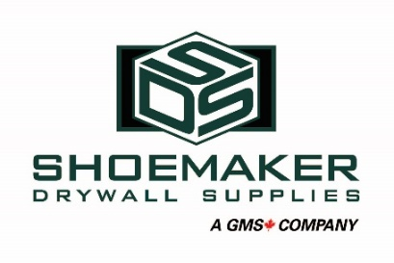
Shoemaker Drywall Supply is Western Canada’s premier supplier of building materials. Our team is made up of dedicated and hardworking individuals who together create a rewarding and welcoming work environment.
Our Cranbrook location is currently looking for highly motivated and customer-focused individuals with a Class 1 or 3 license with Air Brake endorsement for the role of Delivery Driver. Drivers are responsible for the safe operation of a commercial vehicle and the transportation of building materials and the placement on customer job sites. Together with other team members, the Driver works to exceed customer expectations.
Duties & Responsibilities:
- Perform circle-checks and complete logbook entries
- Ensure proper vehicle maintenance and servicing
- Verify load security and accuracy
- Communicate professionally with customers, co-workers, and trades on job sites
- Maintain contact with dispatch and work to resolve issues as they arise
- Prepare trucks for reloading and assist warehouse staff as needed
- Transport goods following rules of the road and representing the company to the highest standards
- Deliver materials as directed by customers
- Prioritize personal safety and the safety of all around you
- Act as an ambassador of the company
- Follow all regulations, company policies, and procedures
- Other duties as assigned
The successful candidate must possess:
- Valid Class 1 or 3 driver’s license with air brake endorsement
- Able to drive standard transmission
- Current clean driver’s abstract
- Effective written and oral communication skills
- Knowledge of basic mathematics
- Basic hand tool skills
- Completion of high school preferred
Physical requirements include:
- Able to lift and carry heavy loads
- Sit for long periods of time
- Frequent climbing up and down stairs
- Push, pull, bend and twist to transfer materials

